123 Belmont Drive SW • Leesburg; Virginia 20175

communi.knews@gmail.com

March 13, 2024

FOR IMMEDIATE RELEASE

CONTACTS: Laura K. Nickle 571-294-8536 Cameron Carey 703-507-0883

THE IDI GROUP CELEBRATES START OF CONSTRUCTION ON $110 MILLION
BELMONT LOGISTICS CAMPUS IN WOODBRIDGE

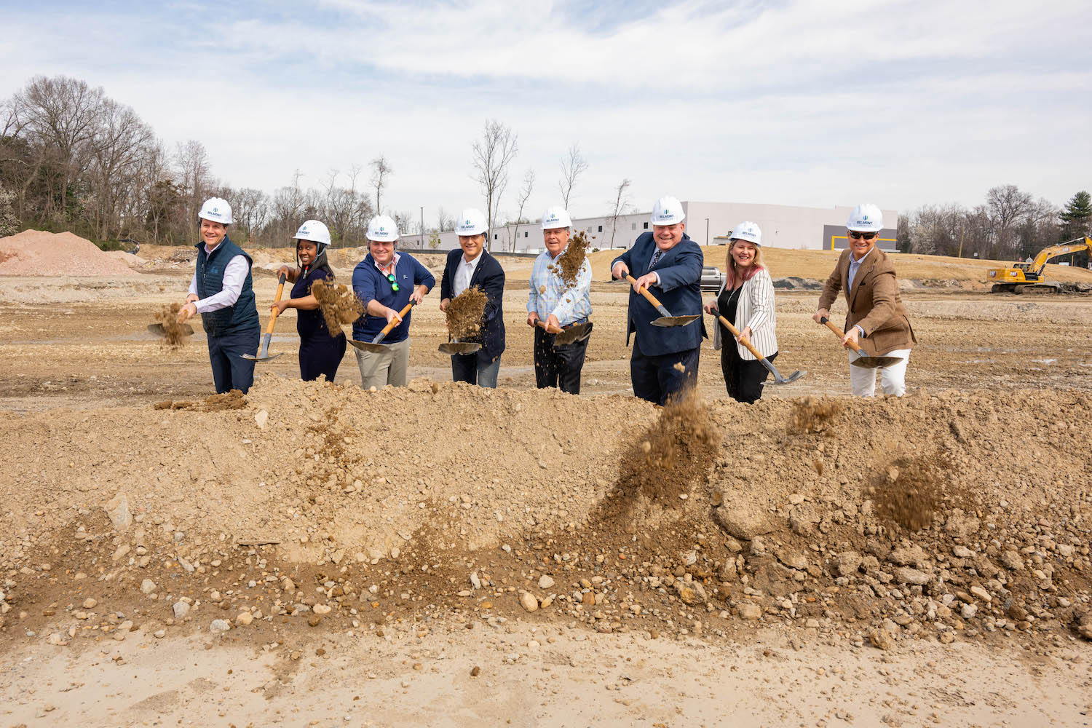
Celebrating the Belmont Logistics groundbreaking (from left to right): Enrico Cecchi, IDI; Woodbridge District Supervisor Margaret Franklin; Nick Carosi IV, Arbon & Carosi; Carlos Cecchi, IDI; Nick Carosi III, Arbon & Carosi; Prince William Chamber of Commerce President Robert Sweeney, Christina Winn, Prince William County Economic Development & Tourism; John Cecchi, IDI. (Photo by Max Taylor)

Woodbridge, VA -- The IDI Group Companies (IDI) and its development partners celebrated the start of construction on Belmont Logistics in Woodbridge, Va. on March 13 with local leaders from Prince William County. Belmont Logistics, a state-of-the-art, Class A industrial complex consisting of three buildings totaling 416,000 square feet on a 36.6-acre campus, represents $110 million in capital investment toward e-commerce logistics infrastructure, and is the only new industrial space delivering in 2024 along Northern Virginia’s I-95 corridor.

Construction Begins at Belmont Logistics...2

Belmont Logistics is the latest Woodbridge project by The IDI Group Companies, the firm behind the successful development of multifamily residential communities Rivergate North and Viridium, and the future Riverside Crossing town center, all in North Woodbridge. “This type of development is vital to support economic growth in the region,” said IDI Managing Director Enrico Cecchi. “We anticipate that its scope and connectivity to the region will make it an ideal choice for companies needing a pivotal location for e-commerce, with its easy access to transportation and other services they require,” he added.

Belmont Logistics is being developed in a joint venture with the landowners, ACD Precast, LLC and the Carosi family. The flexible warehouse facilities will be contained within three tilt-up concrete buildings to be built in two phases over a period of approximately three years. The first phase, a 110,000-square-foot warehouse on 9.48 acres, is expected to be completed by the end of this year, with the balance of the project slated for completion in 2026. The redevelopment of the current site will expand setbacks from Dawson Beach Road, creating an attractive landscape buffer. The location will offer 540 automobile parking spaces and approximately 40 trailer parking spaces, with Phase 2 including an additional 55,000 square feet of outdoor storage space.

Belmont Logistics is situated adjacent to a key road network just southeast of Richmond Highway (US Route 1) at the northeastern gateway into Prince William County. The site offers excellent connectivity to I-95, with two separate exits within ¾ mile of the site. Due to its proximity to the core DMV region, only 30 miles from Dulles International Airport and 20 miles from Reagan National Airport, Belmont Logistics is situated to appeal to a variety of potential tenants and uses.

Financing for the project is provided by Keystone National Group. The general contractor for Belmont Logistics is RW Murray of Manassas, Virginia. It was designed by MGMA of Falls Church, Virginia. Leasing and property management are being handled by JLL of McLean, Virginia.

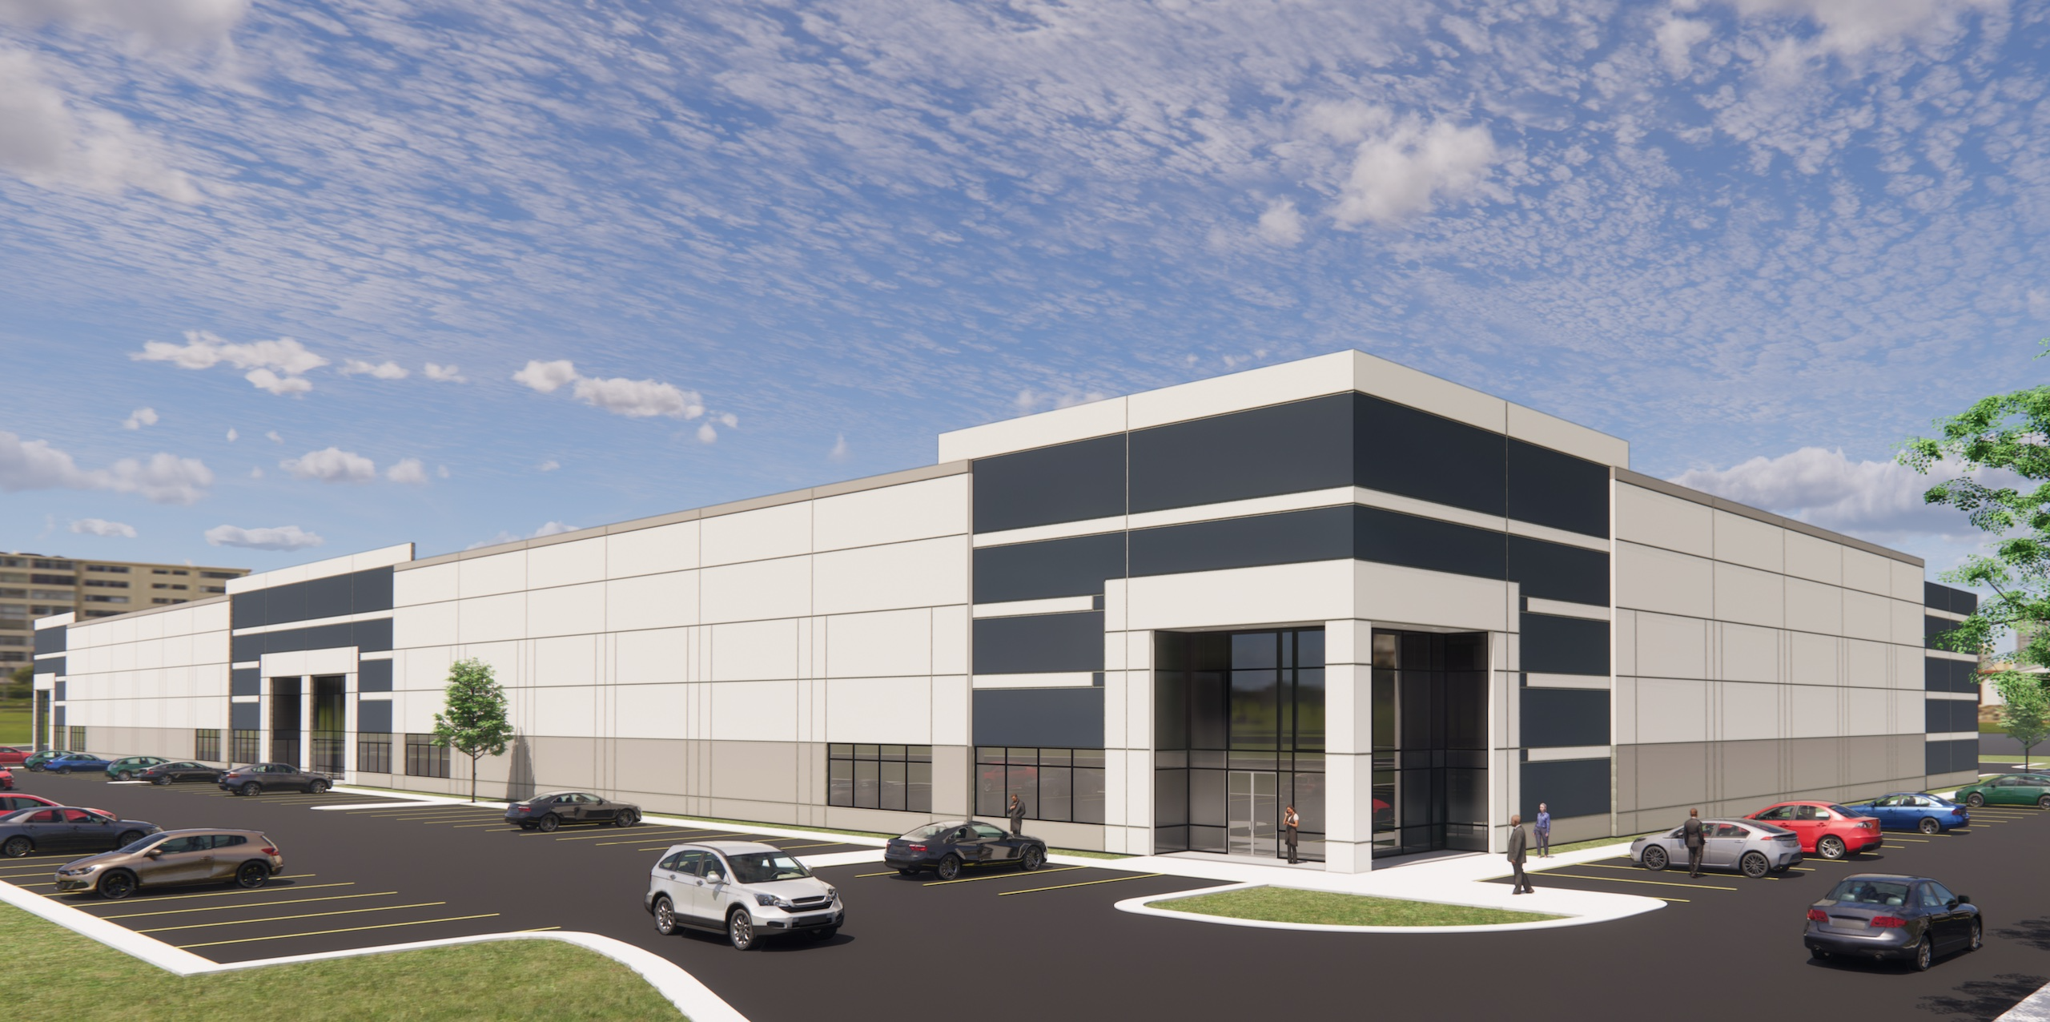
Rendering of Belmont Logistics
Construction Begins at Belmont Logistics...3

About the IDI Group Companies

Since 1975, IDI has been at the forefront of developing lifestyle communities in the Washington DC metropolitan area, with a portfolio that includes more than 14,000 multifamily homes in 28 different communities. In addition to its residential portfolio, IDI has developed significant commercial projects, including Techworld, Rosslyn Center, Ballston Metro Center, the Renaissance Hotel, Vista International Hotel and Leisure World Plaza shopping center. Also in the planning stages is Riverside Crossing, a 19-acre town center project in North Woodbridge. Based in Arlington, Va., IDI has earned dozens of industry awards for design, construction, management, communications and customer satisfaction, including J.D. Power & Associates’ highest customer satisfaction award. More about IDI can be found at idigroup.com.

