123 Belmont Drive SW • Leesburg; Virginia 20175

communi.knews@gmail.com

May 23, 2023

FOR IMMEDIATE RELEASE

CONTACTS: Laura K. Nickle 571-294-8536 Cameron Carey 703-507-0883

THE IDI GROUP CELEBRATES COMPLETION OF THE FLATS AT BOULEVARD VI
WITH RESIDENTS AND FAIRFAX ELECTED OFFICIALS

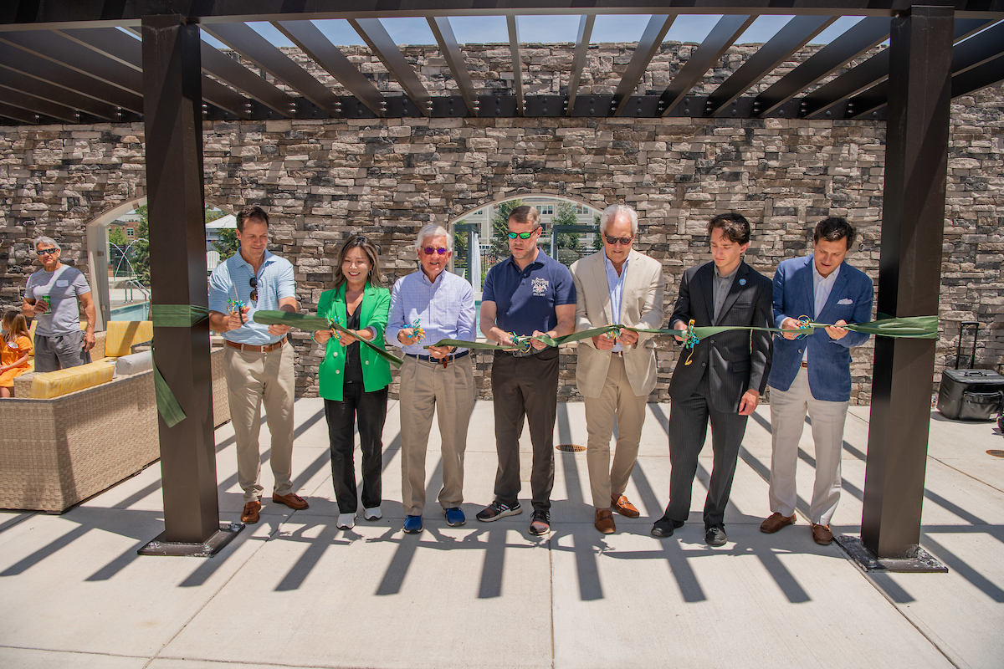

Fairfax, VA -- The IDI Group (IDI) celebrated the completion of The Flats at Boulevard VI, their 137-unit condominium community that was sold out just as the second phase was completed last month. Cutting the ribbon during a community cookout for residents at The Flats were, from left to right: Enrico Cecchi, IDI; City of Fairfax Councilmember and acting Mayor So Lim; Fairfax Councilmember Tom Ross; Fairfax Councilmember Jeff Greenfield; Project Manager Patrick Rhodes, IDI; Fairfax Councilmember Billy Bates; and Carlos Cecchi, IDI.

IDI is developing Boulevard VI on 18.5 acres of land owned by the Catholic Diocese of Arlington, formerly occupied by both Paul VI and Fairfax High Schools, as well as George Mason University.
IDI’s Boulevard VI development plan preserves and adapts the original 1934 portion of the

-more-
school building into 24,000 square feet of community and office space, with another 20,000 square feet of retail pad space already sold. Other residential offerings include 115 townhomes and seven single-family homes being developed by NVR.

The historic lawn in front of the original school building is being preserved as a village green that will host events. Boulevard VI will also include five pocket parks, including two on-site playgrounds, an outdoor fitness area, a perimeter biking/walking path, and historical informational signage to illuminate the site’s history.

About the IDI Group Companies

Since 1975, Arlington-based IDI has been at the forefront of developing lifestyle communities in the Washington DC metropolitan area, with a portfolio that includes more than 14,000 multifamily homes in 28 different communities. More about IDI can be found at idigroup.com.

#####

