123 Belmont Drive SW • Leesburg, Virginia 20175

communi.knews@gmail.com

January 20, 2023

FOR IMMEDIATE RELEASE

CONTACTS: Laura K. Nickle 571-294-8536 Cameron Carey 703-507-0883

RESIDENTS BEGIN MOVING INTO THE FLATS AT BOULEVARD VI AS IDI COMPLETES THE
SALE OF TWO PADS ACCOMMODATING 20,000 SQUARE FEET OF NEW RETAIL SPACE

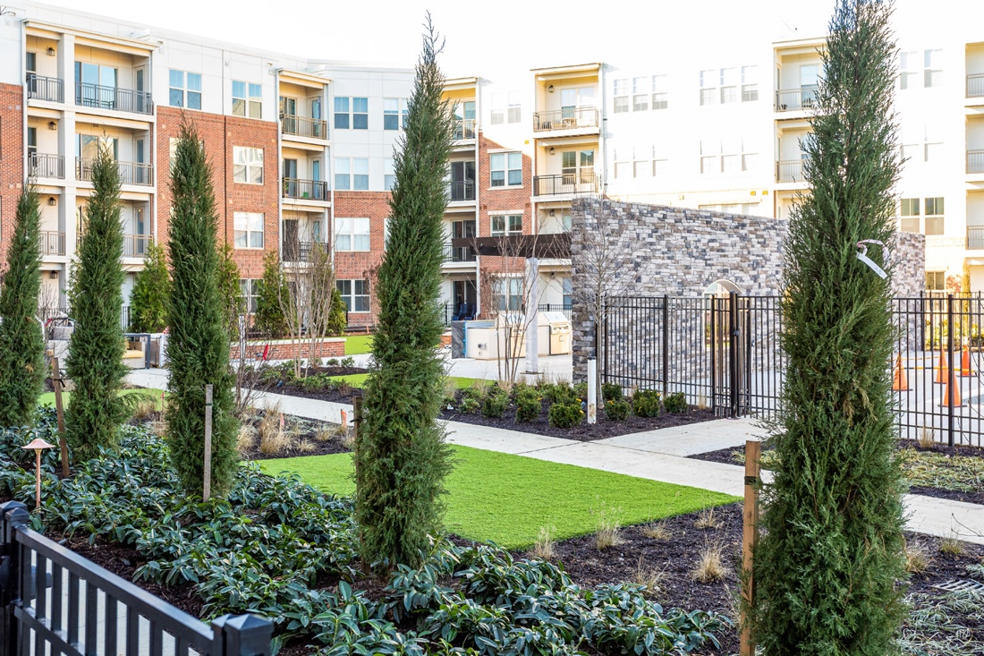
Boulevard VI Exterior.
Photo Credit: Christopher Spillman

Fairfax, Va – The IDI Group (IDI) has completed construction on The Flats, a two-building luxury condominium community and part of the much-anticipated Boulevard VI that IDI is developing in the City of Fairfax. With fewer than 10 of the community’s 137 homes still available, residents have begun moving in as IDI puts finishing touches on the community’s green spaces. IDI also announced the sale of the two retail pads that flank the historic school building as work begins on the adaptive reuse of that structure into a showcase for a new destination retail operation.

“We’re excited to see the plans come to life and to see the response to this new community,” said Enrico Cecchi, Managing Director. “The fact that The Flats outsold every other new home community in the region in 2021 and that there are only a few homes left as we open is a much appreciated testament to the vision we had for what this important site could be,” he added.

IDI also announced the sale of the two available retail pads to Ganges Fairfax, LLC., and to Jeff and Anna Moon. The pad purchased by Ganges Fairfax, LLC. will feature a 20,000-square-foot Learning Experience franchise, an early childhood learning and daycare center. Plans for the pad bought by Jeff and Anna Moon will likely include a mix of retail operations.

IDI is developing Boulevard VI on 18.5 acres of land owned by the Catholic Diocese of Arlington, formerly occupied by both Paul VI and Fairfax High Schools, as well as George Mason University.

The architecture of The Flats is meant to ground the community in both the history and the present of its surroundings. Prices ranged from the low $300s to the low $500s for the variety of floor plans, which includes one- and two-bedroom floor plans. Other features include nine-foot ceilings, a spacious balcony for almost all units and energy-efficient lighting, windows, and mechanical systems. The homes include quality interior unit finishes and a variety of optional available finish and fixture upgrades and garage parking.

On-site amenities include: a party room with catering kitchen; a club room; a fitness center with cardio and weight equipment; an on-site management office; business work stations; secured building access; interior bicycle storage; an outdoor pool with swim lane & cabanas; an outdoor BBQ grilling area; a fire pit; and seating and garden areas.

Interested purchasers can schedule appointments to visit the sales center by visiting the website at BoulevardVI.com. McWilliams Ballard of Alexandria, Va. is conducting sales and provided the included sales data and conclusions. Designed by Heffner Architects of Alexandria, Va., The Flats’ general contractor is John A. Moriarty & Associates of Arlington, Va.
Boulevard VI Development Preserves and Adapts the Past for Today’s Lifestyle Needs

IDI’s Boulevard VI development plan preserves and adapts the original 1934 portion of the school building into 24,000 square feet of community and office space, plus 20,000 square feet of retail space. In addition to The Flats, residential offerings will include 115 townhomes and seven single-family homes. The historic lawn in front of the original school building is being preserved as a village green that will host events.

Boulevard VI will also include five pocket parks, including two on-site playgrounds, an outdoor fitness area, a perimeter biking/walking path, and historical informational signage to illuminate the site’s history.
About the IDI Group Companies

Since 1975, IDI has been at the forefront of developing lifestyle communities in the Washington DC metropolitan area, with a portfolio that includes more than 14,000 multifamily homes in 28 different communities. IDI recently completed Watermark, a luxury boutique condominium in Alexandria; The Enclave, a two-building condominium in the City of Fairfax and Virdium, the second of two luxury apartment buildings on the Occoquan waterfront in Woodbridge. Also underway is the redevelopment of Huntington Club into a transit-oriented mixed-use development next to Huntington Metro in Alexandria, as well as Riverside Station, a 19-acre town center project in North Woodbridge. IDI and its communities have earned dozens of industry awards for design, construction, management, communications and customer satisfaction, including J.D. Power & Associates’ highest customer satisfaction award. More about IDI can be found at idigroup.com.

