123 Belmont Drive SW • Leesburg, Virginia 20175

communi.knews@gmail.com

September 22, 2022

FOR IMMEDIATE RELEASE

CONTACTS: Laura K. Nickle 571-294-8536 Cameron Carey 703-507-0883

PTM Partners and The IDI Group Launch Leasing at Viridium,
the Newest Riverfront Development in Woodbridge, VA

Project Brings 318 New Apartments with Opening Scheduled for November

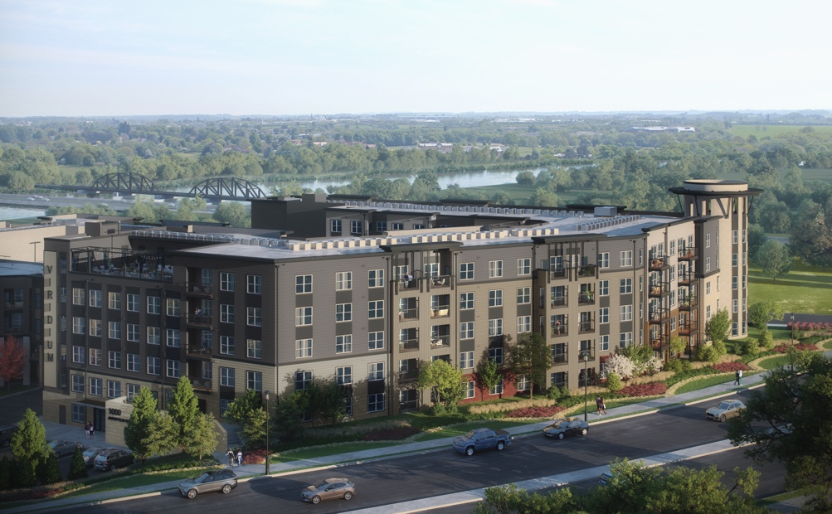

Woodbridge, VA – Co-developers PTM Partners (PTM), an ESG-focused real estate development and investment firm, and The IDI Group Companies (IDI), a premier Washington D.C. developer, announced the launch of leasing at the newest luxury riverfront apartment complex, Viridium, located at 1000 Annapolis Way in Woodbridge, VA. The mid-rise residential complex is comprised of 318 units with an unrivaled amenity offering in the Woodbridge marketplace. The project began construction in Q2 2021, and the first phase is scheduled to be completed and available for move-ins this November.

"Viridium is truly transforming this neighborhood by offering its residents an affordable opportunity to experience luxury and convenience through its spacious apartments, best-in class amenities, and scenic and accessible location,” said Michael Tillman, Chief Executive Officer at PTM. “Through our partnership with IDI, the completion of Viridium at Rivergate contributes to the economic welfare of Prince William County and speaks volumes to the growth of the surrounding community, all while still maintaining over 40 percent of the site area as open space, including landscaped gardens, recreational facilities and more.”

Viridium is part of a two-phase project, with its sister property, Rivergate North, also developed by IDI. The property was completed in May 2018 and consists of 402 Class A apartments. Upon completion of Viridium, the overall complex will have 720 units across two buildings.

Leasing Opens at Viridium on the Occoquan...2

“This beautiful building is the culmination of more than 15 years of creative planning for this prime site, and its successful completion is a direct result of our ability to pivot and reinvent under changing market conditions,” said IDI Managing Director Carlos Cecchi. “We’re thrilled to have brought in great partners that enabled us to see our vision through, and to know that we’ve created a wonderful lifestyle opportunity for our new residents,” he added.
With architecture by Heffner Architects, the first-class community caters to residents seeking a unique lifestyle in the up-and-coming Prince William County. More details on the project are outlined below, including an array of resort-style amenities:

- Junior one-bedrooms ranging from 592 square feet to three-bedrooms, two-baths starting at 1,109 square feet
- Health and fitness center
- Co-working format in the business lounge
- Conference room
- Club lounge
- Video game lounge
- Theater
- Pet grooming facility
- Dog park
- Rooftop terrace
- Resort inspired outdoor pool with sun deck
- Putting green and cornhole
- EV charging stations

Adjacent to the Occoquan River, Viridium is ideally located near shopping centers, Potomac Mills and Stonebridge at Potomac Center, as well as being easily accessible via major commuter routes I-95, Route 1 and the Woodbridge Virginia Railway Express train station.

Prices for Viridium range from $1,800 per month up to $4,300, depending on size and number of bedrooms. Leasing and property management are being spearheaded by Bell Partners. For more information, please inquire here: https://viridiumapts.com/

ABOUT PTM PARTNERS
PTM Partners (“PTM”) is an ESG-focused real estate investment and development firm based in South Florida. With more than $2 billion in developments, PTM seeks community-oriented development opportunities that create substantial value for its residents, partners, and investors. With an eye towards long-term value creation for all stakeholders, PTM focuses on making investment decisions that balance reputation, long-term profitability, and social impact. For more information, visit www.ptmpartners.com.

ABOUT THE IDI GROUP
Since 1975, IDI has been at the forefront of developing lifestyle communities in the Washington DC metropolitan area, with a portfolio that includes more than 14,000 multifamily homes in 28 different communities. IDI recently completed Watermark, a luxury boutique condominium in Alexandria; The Enclave, a two-building condominium in the City of Fairfax; and is about to deliver the first phase of luxury condominiums at The Flats at Boulevard VI, its mixed use community in the heart of Fairfax. Also underway is the redevelopment of Huntington Club into a transit-oriented mixed-use development next to Huntington Metro in Alexandria, as well as the Riverside Station, a 19-acre town center project in North Woodbridge. IDI and its communities have earned dozens of industry awards for design, construction, management, communications and customer satisfaction, including J.D. Power & Associates’ highest customer satisfaction award. More about IDI can be found at idigroup.com.
###

