123 Belmont Drive SW • Leesburg; Virginia 20175
communi.knews@gmail.com 571-294-8536

March 15, 2021

FOR IMMEDIATE RELEASE

CONTACTS: Laura K. Nickle 571-294-8536 Cameron Carey 703-507-0883

FAIRFAX HIGH SCHOOL STUDENTS ADORN NEW CONSTRUCTION SITE WITH MURALS CELEBRATING THE CITY OF FAIRFAX

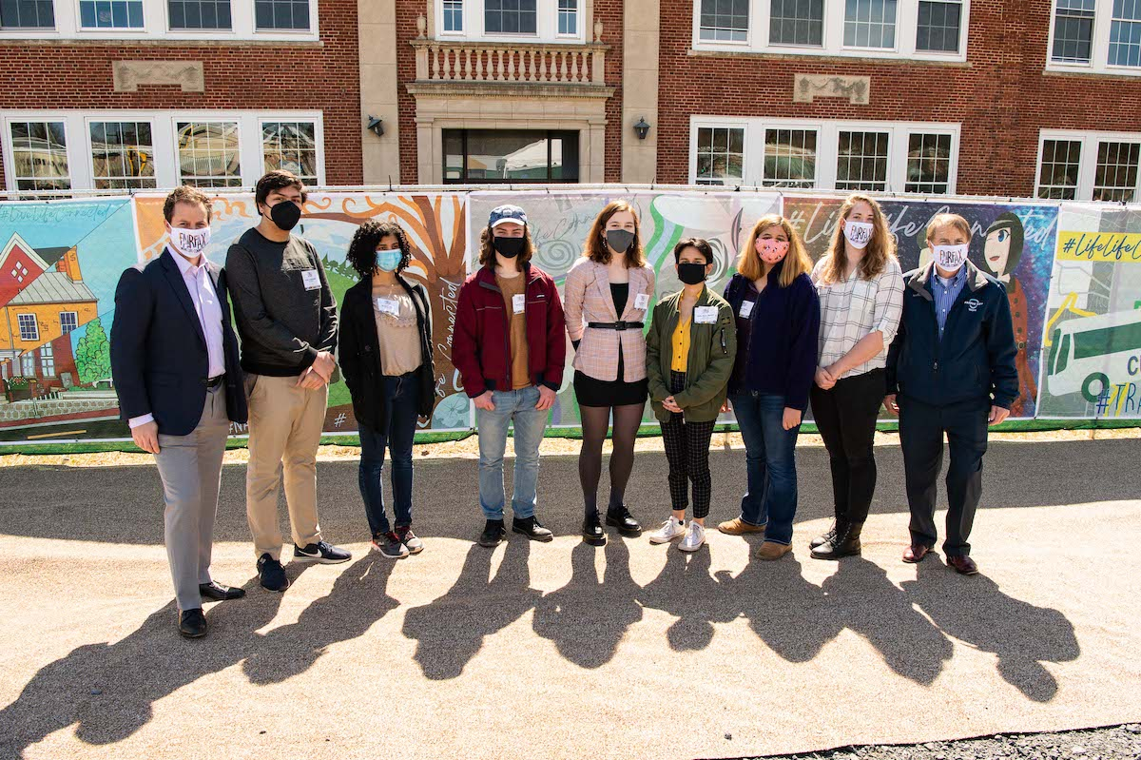

Fairfax, Va. -- Fairfax High School student artists and their teacher joined developer IDI and Fairfax officials for the unveiling of a series of murals celebrating Fairfax. The 27 murals are displayed on the construction fence of Boulevard VI, which IDI is developing on the site of the former Paul VI High School. Pictured, left to right: Enrico Cecchi, IDI; Arian Assadzadeh; Rockett Beeson; Austin Eilbert; Sarah Bird; Sofia Mesa-Morales; Isabela Colon-Mathews; teacher PJ Naber; and Fairfax Mayor David Myer. Photo by Max Taylor Photography.

