123 Belmont Drive SW • Leesburg; Virginia 20175
communi.knews@gmail.com 571-294-8536

March 15, 2021

FOR IMMEDIATE RELEASE

CONTACTS: Laura K. Nickle 571-294-8536 Cameron Carey 703-507-0883

FAIRFAX HIGH SCHOOL STUDENTS ADORN NEW CONSTRUCTION SITE WITH MURALS CELEBRATING THE CITY OF FAIRFAX
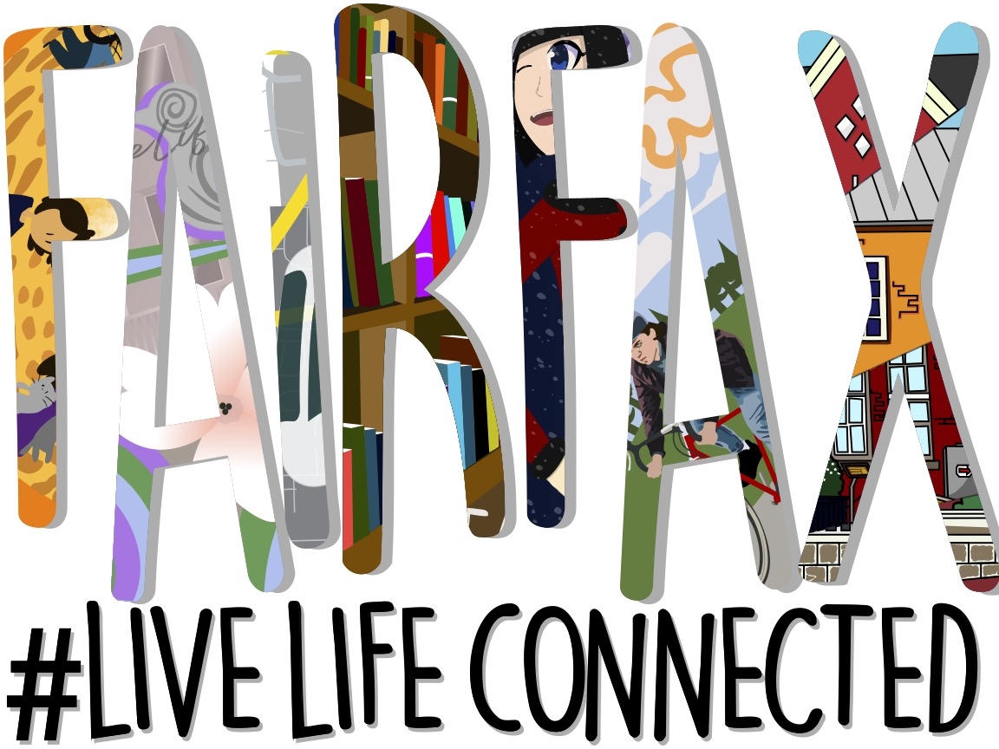

The opening mural in the series of eight that will be repeated along the Boulevard VI construction fence; artwork created by Sofia Mesa-Morales and her teacher PJ Naber.

Fairfax; Va., March 15 – As The IDI Group’s (IDI) construction on The Flats at Boulevard VI begins, passersby will undoubtedly notice a new addition to some 250 feet of construction fencing along Fairfax Boulevard. Seven students from Mrs. PJ Naber’s digital arts class at Fairfax High School created murals depicting different aspects Fairfax City has highlighted in its “#LiveLifeConnected” hash tag. The program was managed and funded by IDI to honor the site’s historic importance as an educational center as well as the unique quality of life its Fairfax location offers.

A March 13 event unveiled the series of eight 6 x 8 murals that will be repeated along the fencing and marked the official start of Boulevard VI, the 18.5-acre mixed use community IDI is developing on land owned by the Catholic Diocese of Arlington on property formerly occupied by Paul VI High School, and before that, by Fairfax High

School. The event was kept small due to Covid-19 but included the students, their teacher and city officials, including Mayor David Meyer and several council members.

“The former Fairfax High School site has come full circle. My colleagues on City Council and I are very excited to see the creative talent of current Fairfax High School students on display at this adaptive reuse and redevelopment project,” said Fairfax Mayor David L. Meyer. “The students’ artwork conveys themes that are foundational to the City of Fairfax, and their portrayal of our community accurately reflects the traits our diverse citizenry values most.” he continued.

“This was truly one of those win-win opportunities. We are honored that our Boulevard VI project will celebrate Fairfax on these beautiful art panels - and like all passersby, to be uplifted by them every day as we work on this new community,” said IDI Managing Director Enrico Cecchi. “We hope the students and their teacher benefitted from a wonderful artistic process and that the students learned the power and value of their own vision and creativity,” he added.

Boulevard VI Art Panels Illustrate Connectivity in Fairfax City
Immediately following the unveiling, a crew began installation of the 27 banners on the Boulevard VI construction fencing. Each panel was created digitally by an individual student to depict how Fairfax residents live life connected in seven specific areas. The images as well as photos of the participating students can be found at www.idigroup.com/fairfaxlivelifeconnected.

“This was an amazing opportunity as well as an exciting challenge for my students. I am so very proud of the resilience my students have demonstrated as they face the requirements of social distancing, wearing masks, and the unprecedented challenges of virtual learning and collaboration,” said PJ Naber, the Fairfax High School teacher and fine arts chair who supervised the students’ efforts. “Their works are a reminder of our sense of community and that art has a strong presence and role within the City of Fairfax,” she added.

History (Kaia Collins): “For this piece, I was inspired by the lasting grace and historical importance of these three buildings (City of Fairfax Regional Library, Historic Blenheim and Fairfax Museum and Visitor Center). The spliced look allows for them to be showcased and appreciated equally.”
Nature (Austin Eilbert): “Creating my artwork “Nature” I aimed to represent the diverse people and activities within Fairfax City’s natural world. Inspired by early 20th century Art Nouveau this piece is irregular and non-symmetrical, to mirror the complexities of nature.”
The Arts (Sarah Bird): “My work was meant to depict what I feel is important aspects of the arts around Fairfax. Some of them you might recognize! There's "The Dancer" by Chris Erny, "Peace Bird" by Micheal Cain, and my personal favorite, "Dogwoods" by Amanda Lutz. I also took inspiration from the signal box wraps that can be seen around Fairfax. Dogwoods is so simplistic but at the same time it draws the eye, so I was very excited to include some of the flowers from it in this piece. Seeing art around Fairfax always makes me happy, it makes everything lively and interesting. I had a lot of fun making this piece, and I hope you like it too!”

Socializing (Isabela Colon Matthews): “When I learned about the “City of Fairfax Opportunity” promotion of Live Life Connected, I thought it could be a fun idea, so I volunteered to focus on the socializing theme. At first I had a bit of trouble thinking about a main subject for my piece; I had a basic idea but that wasn’t enough. My teacher provided us with drawings that were categorized with the themes which inspired me. I designed the characters wearing warmer clothing because I had the theme of winter imprinted in my mind since I was crafting the drawing around the festive season. Funny enough, the outfits themselves are inspired by clothing from one of my favorite video games, the variety of clothing styles allowed me to mix the different styles to make distinctive outfits. My personal favorite is the girl on the left’s design, creating the pattern was certainly a challenge. I was thinking of letting them walk down a city street, but when I tried placing them in that setting I didn’t like the result. I still wanted to make it look like they were walking down a city street, so I chose to use the effect of bright lights, in the distance, lining up around them. I like to think that there’s a light show going on around the city they’re walking in. I included falling snow for an additional movement effect which was like icing on the cake.”
Transportation (Sofia Morales): “Sustainable environmentally-friendly transportation in Fairfax means a lot to me. I was an avide CUE Bus rider before COVID-19, and if I could, I would bike everywhere and anywhere. I believe the CUE Bus plays a huge role in aiding citizens of Fairfax to get where they need to go at a reasonable cost (especially if you’re a student like me!). Not only is public transit infinitely better for the environment, it gives back to the city, economically and metaphorically.”
Education (Arian Assadzadeh): “Education is one of if not the most important thing in one's life. Education shows you your passion and carves the road for your future. I am always excited to learn. Education was always important to me, and this project allowed me to convey what education was for me.”
Volunteerism (Rockett Beeson): “While developing the protosketch for this artwork, I wanted to use a shape that envelopes the actions and had a roundabout form to link the characters together. By using a circle I was able to center the focus on the sun and the name "Fairfax" which set the tone for the rest of the artwork. The characters in the artwork were of varying race, gender, and had a different set of clothing. I did this to portray the divers and open community Fairfax has and wants to represent. As the final detail, I used warm, yellow tones to portray Fairfax's calm and welcoming tone that has been a part of its charm for much of my life.”

More About Boulevard VI by IDI

IDI’s Boulevard VI development plan preserves and adapts the original 1934 portion of the school building into 12,000 square feet of destination retail, with another 20,000 square feet of retail planned for food, shops and services. Residential offerings will include the 144 condominium homes of The Flats, as well as 115 townhomes and seven single-family homes. The historic lawn in front of the original school building is being preserved as a village green that will host events. Boulevard VI will include five additional pocket parks, two on-site playgrounds, an outdoor fitness area, a perimeter biking/walking path, and historical informational signage to illuminate the site’s history. For more information, visit BoulevardVI.com.

Since 1975, IDI has been at the forefront of developing luxury condominiums in the Washington, D.C. metropolitan area. The IDI portfolio includes more than 14,000 multifamily homes in 28 different communities.

#####

