123 Belmont Drive SW • Leesburg; Virginia 20175

communi.knews@gmail.com 571-294-8536

FOR IMMEDIATE RELEASE

CONTACTS: Laura K. Nickle 571-294-8536 Cameron Carey 703-507-0883

EARLY SALES BRISK FOR THE FLATS AT BOULEVARD VI IN FAIRFAX

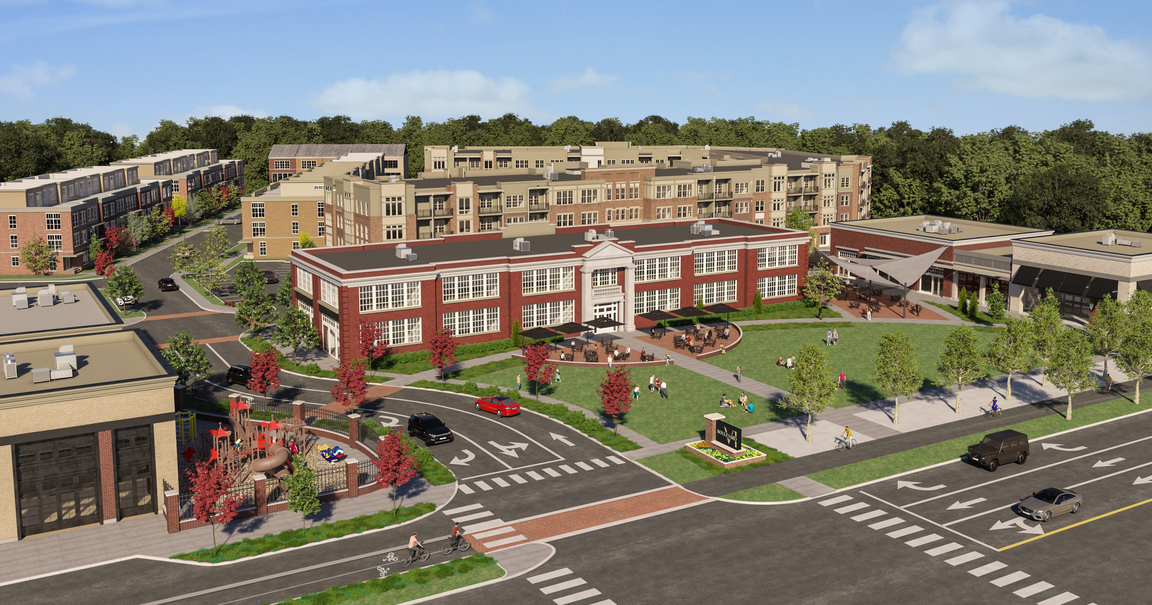
Rendering of Boulevard VI showing The Flats behind. Courtesy of IDI.
Fairfax, Va., March 15 – More than 60 percent of the first available condominium homes have been presold as The IDI Group Companies (IDI) today celebrated the official start of construction on The Flats at Boulevard VI in the city of Fairfax. The 144-unit, four-story luxury condominium community, which is currently selling ahead of projections, is part of the new Boulevard VI mixed use community off Fairfax Drive.

IDI is developing Boulevard VI on 18.5 acres of land owned by the Catholic Diocese of Arlington, and formerly occupied by both Paul VI High School and Fairfax High School.
The first component of the new development comprises The Flats, which will be completed in two phases. Phase One will produce 73 condominium homes and is scheduled to be completed in late summer 2022; while Phase Two will produce 71 homes and is slated for late fall of 2022.

Designed by Heffner Architects of Alexandria, Va., the architecture of The Flats at Boulevard VI is meant to ground the community in both the history and the present of its surroundings. A variety of one-and two-bedroom floor plans are available, as well as large luxury two bedroom plus den homes with double balconies. Other features include nine-foot ceilings, a spacious balcony for almost all units and energy efficient lighting, windows and mechanical systems. The homes include quality interior unit finishes and a variety of optional unit upgrades available to the purchasers. The on-site amenities include: a party room with catering kitchen; a club room; a fitness center with cardio and weight equipment; an on-site management office; business work stations; secured building access; interior bicycle storage; an outdoor pool with swim lane & cabanas; an outdoor BBQ grilling area; a fire pit; and seating and garden areas. The homes’ prices range from the low $300,000s to the upper 600,000’s, all of which include an assigned garage parking space.
Interested purchasers can schedule appointments to visit the newly opened sales center by visiting the website at BoulevardVI.com. McWilliams Ballard of Alexandria, Va. is conducting sales. General contractor for The Flats is John A. Moriarty & Associates of Arlington, Va.
Boulevard VI Development Preserves the Past for Modern-Day Living

IDI’s Boulevard VI development plan preserves and adapts the original 1934 portion of the school building into 12,000 square feet of destination retail and includes 20,000 square feet of additional retail, with planned food, shops and services. Residential offerings will include the 144 condominium homes of The Flats, as well as 115 townhomes and seven single family homes. The historic lawn in front of the original school building is being preserved as a village green that will host events.

Boulevard VI will also include five additional pocket parks, two on-site playgrounds, an outdoor fitness area, a perimeter biking/walking path, and historical informational signage to illuminate the site’s history.
About The IDI Group Companies

Since 1975, IDI has been at the forefront of developing luxury condominiums in the Washington, D.C. metropolitan area. The IDI portfolio includes more than 14,000 multifamily homes in 28 different communities. IDI recently completed Watermark, a luxury boutique condominium in Alexandria; The Enclave, a two-building condominium in the City of Fairfax; and Rivergate North, a luxury riverfront apartment building in Woodbridge. Also in various stages of development in Northern Virginia are: a second Rivergate building in Woodbridge; and the redevelopment of Huntington Club into a transit-oriented mixed-use development next to Huntington Metro in Alexandria. IDI and its communities have earned dozens of industry awards for design, construction, management, communications and customer satisfaction, including J.D. Power & Associates’ highest customer satisfaction award. More about IDI can be found at idigroup.com.

#####

