123 Belmont Drive SW • Leesburg; Virginia 20175

communi.knews@gmail.com

December 4; 2020

FOR IMMEDIATE RELEASE

CONTACTS: Laura K. Nickle 571-294-8536 Cameron Carey 703-507-0883

IDI OPENS SALES ON THE FLATS AT BOULEVARD VI IN FAIRFAX

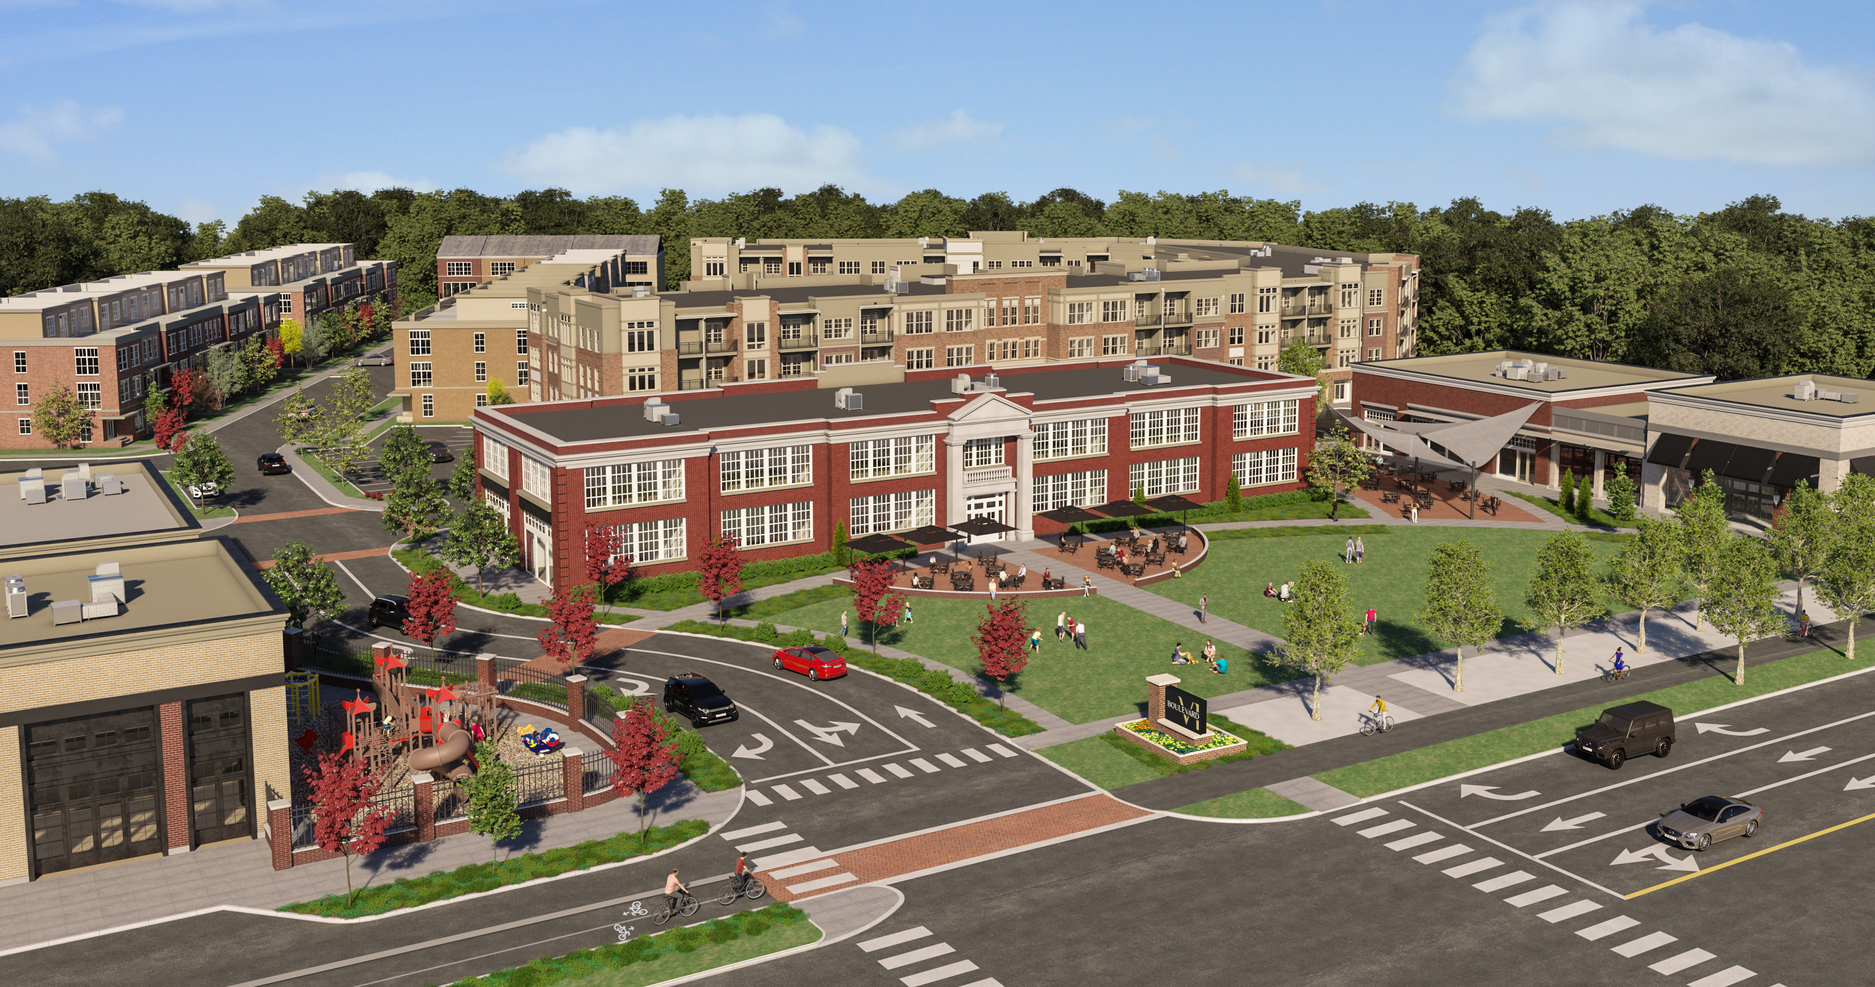
Rendering of Boulevard VI; courtesy of IDI.
Fairfax; Va.– The IDI Group (IDI) has opened sales on The Flats at Boulevard VI, a 144-unit, four-story luxury condominium building that will be the first new project at Boulevard VI in Fairfax. Located along Fairfax Drive in the City of Fairfax, Boulevard VI is the 18.5-acre mixed use community IDI is developing on land owned by the Catholic Diocese of Arlington on property formerly occupied by Paul VI High School, and before that, by Fairfax High School.
“This is an important piece of land for the City of Fairfax; and we are very pleased to reach this early milestone in bringing our vision for it to life;” said Patrick Rhodes; IDI Vice President and Senior Project Manager. Plans call for The Flats at Boulevard VI to be completed in two phases. Phase One will produce 73 condominium homes and is scheduled to be completed in spring 2022; while Phase Two will produce 71 homes and is scheduled to be completed in fall 2023. General contractor for The Flats is John A. Moriarty & Associates of Arlington, Va.
-more-
The Flats Add to Condominium Convenience with Indoor and Outdoor Amenities

Designed by Heffner Architects of Alexandria, Va., the architecture of The Flats at Boulevard VI is meant to ground the community in both the history and the present of its surroundings. A variety of one-and two-bedroom floor plans are available, as well as large combo units. Each home features nine-foot ceilings, a spacious balcony and high efficiency lighting, windows and mechanical systems. The on-site amenities include: an on-site management office; a party room with catering kitchen; a club room; a fitness center with cardio and weight equipment; interior bicycle storage; an outdoor pool with swim lane; an outdoor BBQ grilling area; a fire pit; and seating and garden areas. The homes range from 705-1700 square feet and are priced from the low $300s to the mid $800s.
Interested purchasers can schedule appointments to visit the newly opened Sales Center by visiting their website at BoulevardVI.com. Sales are being handled by McWilliams Ballard of Alexandria, Va.
Boulevard VI Development Preserves the Past for Modern-Day Living

IDI’s Boulevard VI development plan preserves and adapts the original 1934 portion of the school building into destination retail and includes 44,000 square feet of retail, with food and shops. Residential offerings will include the 144 condominium homes of The Flats, as well as 115 townhomes and seven single family homes. The historic lawn in front of the original school building is being preserved as a village green that will host events. Boulevard VI will include five additional parks, two on-site playgrounds, an outdoor fitness area, a perimeter biking/walking path, and historical informational signage to illuminate the site’s history. There will be ample parking for residents, shoppers and for the existing baseball fields at Pat Rodeo Park.
About The IDI Group Companies

Since 1975, IDI has been at the forefront of developing luxury condominiums in the Washington, D.C. metropolitan area. The IDI portfolio includes more than 14,000 multifamily homes in 28 different communities. IDI recently completed Watermark, a luxury boutique condominium in Alexandria; The Enclave, a two-building condominium in the City of Fairfax; and Rivergate North, a luxury riverfront apartment building in Woodbridge. Also in various stages of development in Northern Virginia are: a second Rivergate building in Woodbridge; the redevelopment of Huntington Club into a transit-oriented mixed-use development next to Huntington Metro in Alexandria; and San Marco, an eight-story luxury condominium building on the Georgetown waterfront. IDI and its communities have earned dozens of industry awards for design, construction, management, communications and customer satisfaction, including J.D. Power & Associates’ highest customer satisfaction award. More about IDI can be found at idigroup.com.

#####

