123 Belmont Drive SW • Leesburg, Virginia 20175

communi.knews@gmail.com

October 30, 2020

FOR IMMEDIATE RELEASE

CONTACTS: Laura K. Nickle 571-294-8536 Cameron Carey 703-507-0883

IDI’S WATERMARK WINS BEST BOUTIQUE CONDOMINIUM COMMUNITY
IN BALTIMORE-WASHINGTON REGION FROM DELTA ASSOCIATES
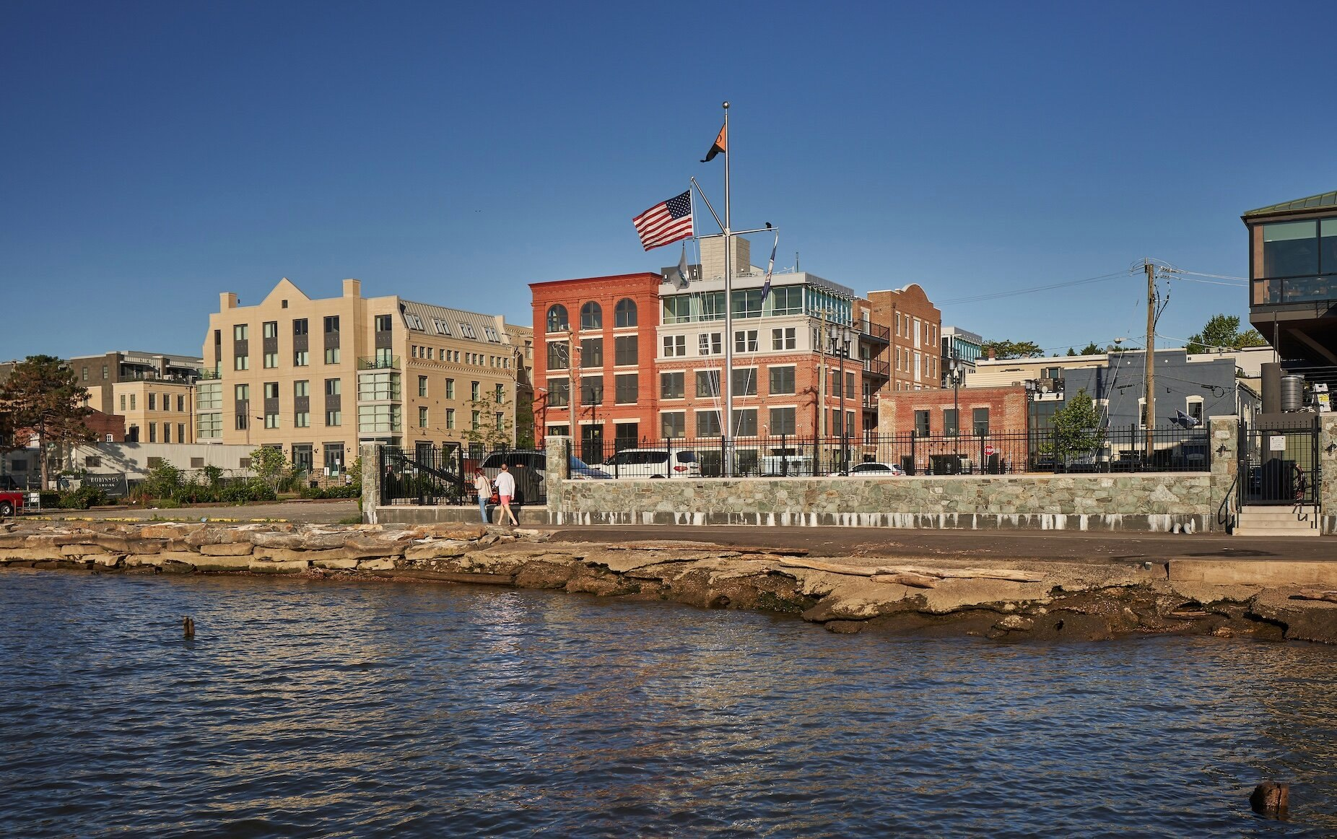
IDI’s Watermark as seen from the Potomac River. Photo by Jeff Wolfram.

Old Town Alexandria, Va., October 30 – Watermark, The IDI Group Companies’ boutique condominium community along the banks of the Potomac River in the heart of Old Town Alexandria waterfront, was named the Best Boutique Condominium Community in the entire Baltimore-Washington region. The award was presented to IDI in a virtual ceremony hosted by Delta Associates as part of their 24th Annual Apartment and Condominium Industry Awards for Excellence.

“Watermark features exquisite elegance and classic comfort in every detail, with thoughtful features in incredibly spacious homes,” said Moustafa Fahmy, Delta Associates’ Multifamily Awards Coordinator. “You can sit back and relax by the fireplace in your smart home while taking in breathtaking views of the waterfront that only this property can offer,” he added. Delta Associates has provided consulting and research services and subscription reports to the commercial real estate industry for more than 35 years. The practice is experienced in apartments, condominiums, office, retail, hotel, and mixed-use properties all throughout the United States.

“We’ve always known Watermark is a winner and we couldn’t be happier to accept this award,” said Carlos Cecchi, managing director for the Arlington-based real estate development company that completed the building this summer. “This building has it all, really – a prime location with water and Old Town views, an appealing design that marries historic charm with modern sensibility, and light-filled open spaces,” he added. All but 2 of the 18 homes have been purchased, while Salon Monte, the flagship salon of celebrated stylist Monte Durham, is now open and operating in retail space on the Union Street side of the building.

All Watermark owners enjoy picturesque water views from a rooftop terrace equipped for outdoor dining and entertaining. Garage parking is provided on the first level of the new building, with access from Union Street. Watermark is fronted by Alexandria’s future Point Lumley Park and is just a block and a half from King Street, allowing residents to enjoy all of the vibrant urban amenities that Old Town has to offer. The building was designed by Rust Orling Architecture, engineered by Christopher Consultants and constructed by John A. Moriarty & Associates, while construction financing was provided by Sandy Spring Bank. Condominium sales are handled by McWilliams|Ballard.

About The IDI Group Companies

Since 1975, IDI has been recognized as the premier developer of condominiums in the Washington, D.C. metropolitan area. The IDI portfolio includes more than 14,000 multifamily homes in 28 different communities. IDI recently completed The Enclave, a two-building condominium in the City of Fairfax, and Rivergate North, a luxury riverfront apartment building in Woodbridge. Also in various stages of development in Northern Virginia are: a second Rivergate building in Woodbridge; the redevelopment of the Paul VI high school site into a new, mixed-use community in the City of Fairfax named Boulevard VI; the redevelopment of Huntington Club into a transit-oriented mixed-use development next to Huntington Metro in Alexandria; and San Marco, an eight-story luxury condominium building on the Georgetown waterfront. IDI and its communities have earned dozens of industry awards for design, construction, management, communications and customer satisfaction, including J.D. Power & Associates’ highest customer satisfaction award. More about IDI can be found at idigroup.com.

#####

