123 Belmont Drive SW • Leesburg, Virginia 20175
communi.knews@gmail.com

October 19, 2020

FOR IMMEDIATE RELEASE

CONTACTS: Laura K. Nickle 571-294-8536 Cameron Carey 703-507-0883

MONTE DURHAM OPENS FIRST SALON AT WATERMARK IN ALEXANDRIA
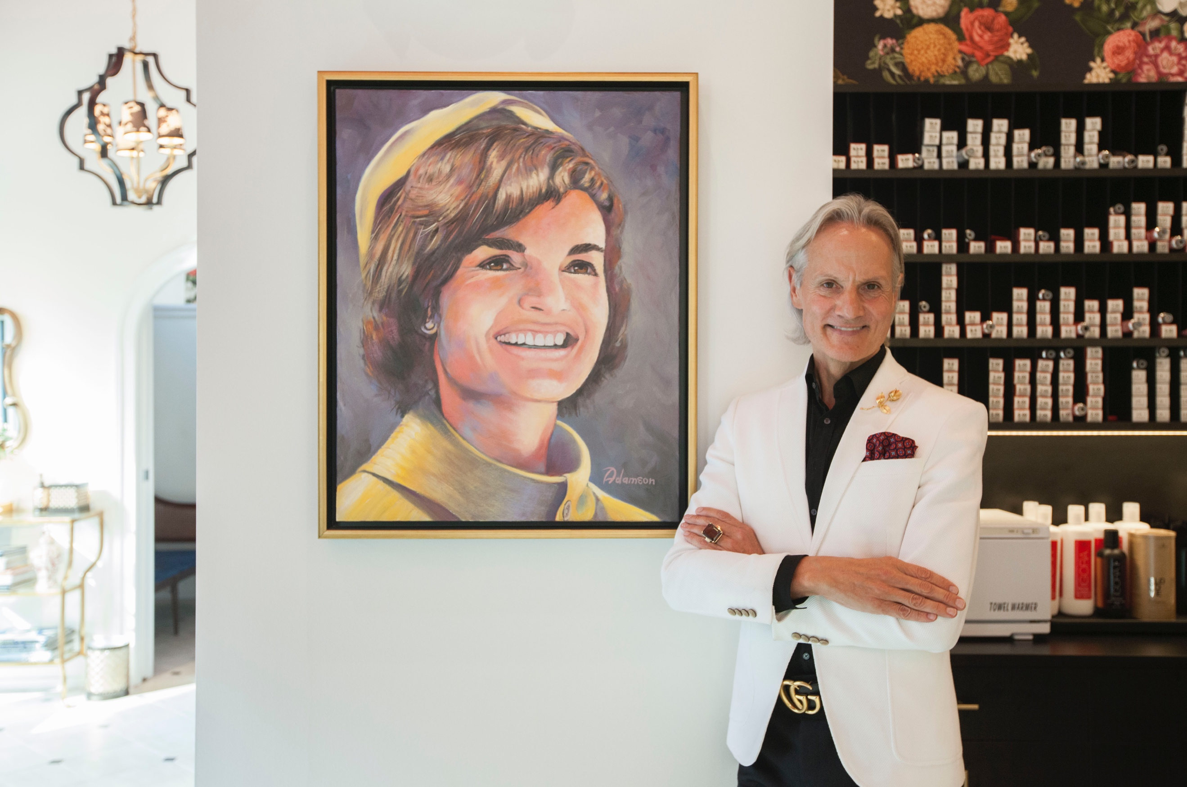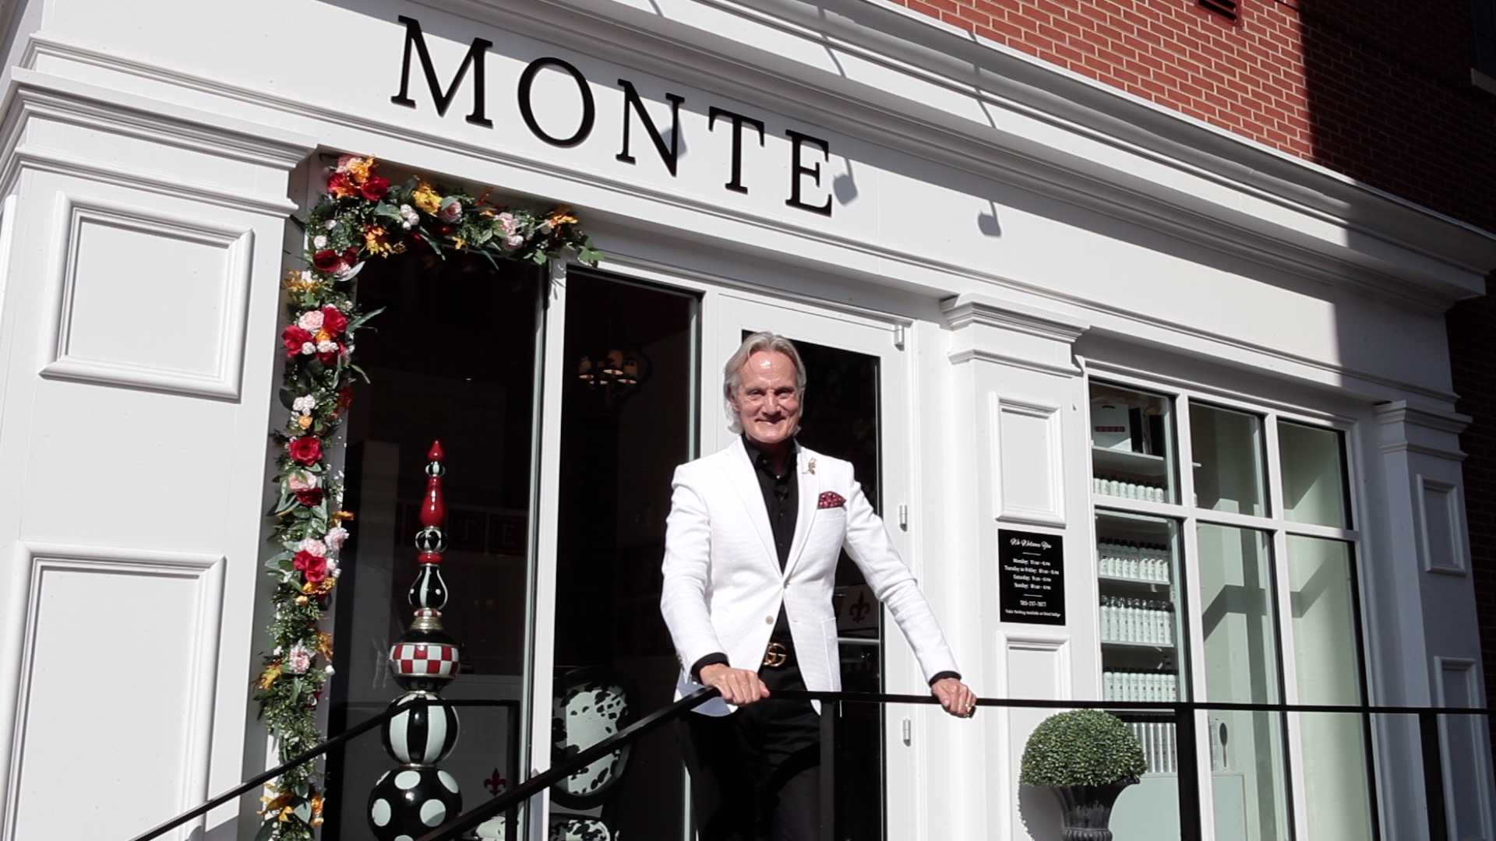
Monte Durham inside and outside his new Watermark salon with his favorite
Jackie Onassis portrait. Photo by Paul Russell.

Old Town Alexandria, Va. – Monte Durham has opened his first hair salon – Salon Monte – in the South Union Street retail space of Watermark, Old Town Alexandria’s exclusive new boutique condominium. Famous for his work as fashion director for TLC’s “Say Yes to the Dress: Atlanta,” and host of “Say Yes to the Prom,” Durham has also launched own hair care line M.O.N.T.E. - used exclusively at the salon.

Durham is best known for being fashion director at Bridals by Lori, the South’s premier bridal salon featured on TLC’s “Say Yes to the Dress: Atlanta.” A native of small-town West Virginia, Durham worked in fashion merchandising and hair styling, then made a name for himself as a Washington, D.C.-based bridal image consultant. His work has appeared in the pages of Washingtonian, Martha Stewart Living, Brides and several other publications. His no-nonsense fashion commentary and sense of humor have made him a favorite and regular guest on both CNN and Fox.

“I could not have chosen a more perfect location than Watermark for Salon Monte,” said Durham. “To be right on Union Street in this gorgeous new building in the heart of Old Town is really a dream come true for me,” he added. The salon offers a full range of services; for more information and scheduling, visit “salonmonte.com.”

Watermark is an exclusive five-story building with 18 homes, completed this summer by The IDI Group Companies of Arlington, Va Owners of the building’s luxurious and spacious condos have been moving in at the same time as Durham; all but three have already been purchased. Watermark is prominently located on Strand Street next to Hotel Indigo, with its east façade facing the Potomac River and its west façade facing historic South Union Street. Watermark is just a block from King Street, allowing residents to enjoy all of the vibrant urban amenities that Old Town has to offer. One additional retail space is available facing Strand Street

The boutique waterfront condominium merges exterior details that reference Alexandria’s historic past with large, modern homes and luxury amenities. The three remaining homes s feature expansive, light-filled open spaces, appointed with modern, finishes and incredible water views. They are equipped with Italian Cucina Craft cabinetry, heated master bath floors, and fireplaces. All Watermark owners can enjoy picturesque Potomac River views from a rooftop terrace equipped for outdoor dining and entertaining. More information is available at watermarkoldtown.com.

Sales are being handled by McWilliams|Ballard of Alexandria. Watermark was designed by Rust Orling Architecture of Alexandria, Va.; John A. Moriarty & Associates of Arlington, Va. is was the general contractor. Christopher Consultants of Fairfax, Va., served as the project’s civil engineers. Construction financing was provided by Sandy Spring Bank.

About The IDI Group Companies

Since 1975, IDI has been recognized as the premier developer of condominiums in the Washington, D.C. metropolitan area. The IDI portfolio includes more than 14,000 multifamily homes in 28 different communities. IDI recently completed The Enclave, a two-building condominium in the City of Fairfax, and Rivergate North, a luxury riverfront apartment building in Woodbridge. Also in various stages of development in Northern Virginia are: a second Rivergate building in Woodbridge; the redevelopment of the Paul VI high school site into a new, mixed-use community in the City of Fairfax named Boulevard VI; the redevelopment of Huntington Club into a transit-oriented mixed-use development next to Huntington Metro in Alexandria; and San Marco, an eight-story luxury condominium building on the Georgetown waterfront. IDI and its communities have earned dozens of industry awards for design, construction, management, communications and customer satisfaction, including J.D. Power & Associates’ highest customer satisfaction award. More about IDI can be found at idigroup.com.

#####

