123 Belmont Drive SW • Leesburg, Virginia 20175

communi.knews@gmail.com

June 25, 2020

FOR IMMEDIATE RELEASE

CONTACTS: Laura K. Nickle 571-294-8536 Cameron Carey 703-507-0883

IDI COMPLETES WATERMARK IN OLD TOWN ALEXANDRIA
First Buyers Move in to Boutique Waterfront Condominium Community
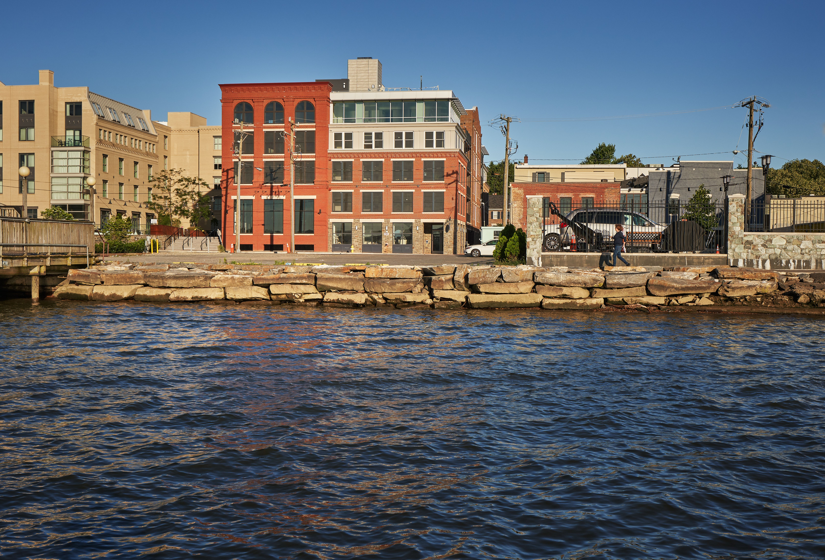
Pictured is the Watermark’s exterior, courtesy of IDI.

Alexandria, Va., June 25– Watermark, The IDI Group’s boutique condominium community along the banks of the Potomac River in the heart of Old Town Alexandria waterfront, announced that construction is complete and the first owners are set to begin moving in.

“We’re very proud as we see to the final details in anticipation of our new owners moving in next week,” said Carlos Cecchi, managing director for the Arlington-based real estate development company. “We’ve created a unique opportunity for our buyers to live large within a small community with a prime riverfront location, and we are thrilled that it’s time for them to move in and start living beautiful lives here.”

The 18-unit luxury condominium merges exterior details that reference Alexandria’s historic past with large, modern homes and luxury amenities to its prominent location on Strand Street facing the Potomac River. The homes themselves feature expansive, light-filled open spaces, appointed with modern, features, fixtures and finishes. All homes have Italian Cucina Craft cabinetry, heated master bath floors, and most have a fireplace. Another feature of the homes at Watermark, is that most homes have water views with others looking into the heart of Old Town Alexandria. All Watermark owners enjoy picturesque water views from a rooftop terrace equipped for outdoor dining and entertaining.

The building also includes two retail spaces. Garage parking is provided on the first level of the new building, with access from Union Street. Watermark is fronted by Alexandria’s future Point Lumeley Park and is just a block and a half from King Street, allowing residents to enjoy all of the vibrant urban amenities that Old Town has to offer.

Sales are being handled by McWilliams|Ballard of Alexandria. Watermark was designed by Rust Orling Architecture of Alexandria, Va.; John A. Moriarty & Associates of Arlington, Va. is the general contractor. Christopher Consultants of Fairfax, Va., served as the project’s civil engineers. Construction financing is provided by Sandy Spring Bank.

About The IDI Group Companies

Since 1975, IDI has been recognized as the premier developer of condominiums in the Washington, D.C. metropolitan area. The IDI portfolio includes more than 14,000 multifamily homes in 28 different communities. IDI recently completed The Enclave, a two-building condominium in the City of Fairfax, and Rivergate North, a luxury riverfront apartment building in Woodbridge. Also in various stages of development in Northern Virginia are: a second Rivergate building in Woodbridge; the redevelopment of the Paul VI high school site into a new, mixed-use community in the City of Fairfax named Boulevard VI; the redevelopment of Huntington Club into a transit-oriented mixed-use development next to Huntington Metro in Alexandria; and San Marco, an eight-story luxury condominium building on the Georgetown waterfront. IDI and its communities have earned dozens of industry awards for design, construction, management, communications and customer satisfaction, including J.D. Power & Associates’ highest customer satisfaction award. More about IDI can be found at idigroup.com.

#####

