123 Belmont Drive SW • Leesburg, Virginia 20175 571-294-8536 communi.knews@gmail.com

February 26, 2018

FOR IMMEDIATE RELEASE

CONTACTS: Laura K. Nickle 571-294-8536; Cameron Carey 703-507-0883

IDI CELEBRATES RIVERGATE NORTH COMPLETION
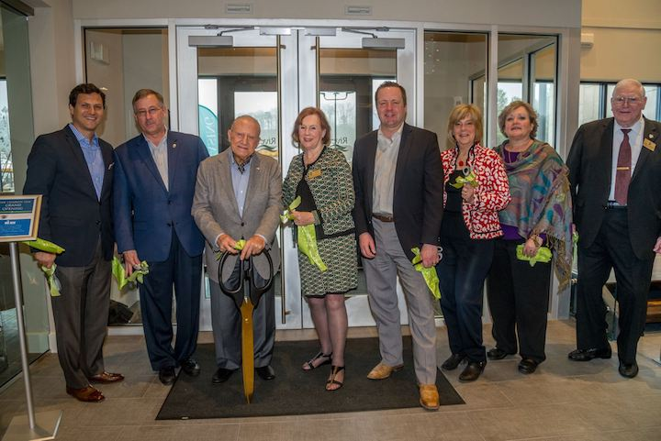
WITH RIBBON CUTTING CEREMONY

AND THE AND RIVERGATE RIBBON IS CUT! Local leaders and development team members joined The IDI Group Companies and new residents at a ribbon cutting for Rivergate North, the first of two luxury residential buildings on the Occoquan River in Woodbridge. From left to right: Carlos Cecchi, Managing Director, The IDI Group Companies; Frank Principi, Woodbridge District Supervisor, Prince William Board of County Supervisors; Giuseppe Cecchi, President and CEO, The IDI Group Companies; Maureen Caddigan, Potomac District Supervisor, Prince William Board of County Supervisors; Corey Stewart, Chairman At-Large, Prince William Board of County Supervisors; Ruth Anderson, Occoquan District Supervisor, Prince William Board of County Supervisors; Debbie Jones, President and CEO, Prince William Chamber of Commerce; and John Jenkins, Neabsco District Supervisor, Prince William Board of County Supervisors. Photo by Liz Roll Photography.

-more-
IDI Celebrates Rivergate North with Ribbon Cutting...2

Woodbridge, Va. – Local leaders and residents joined The IDI Group Companies of Arlington, Va. on February 10 to celebrate the completion of Rivergate North, the first of two luxury residential buildings IDI is developing on the Occoquan River next to the Occoquan Harbor Marina in northern Prince William County, Va. The one-, two- and three-bedroom apartments range from $1,582-$2,621 a month and offer a host of unique amenities and conveniences, and leasing is brisk, according to IDI Managing Director Carlos Cecchi.

The new building is approaching 20 percent leased, with approximately five new tenants moving in per week. In addition to the waterfront views, the wide array of onsite amenities at Rivergate sets it apart: two spacious resident lounges with TVs, pool table, bar and kitchen; state-of-the-art fitness center with cardio and weight-training equipment plus Wellbeats™ virtual fitness classes; fully equipped business center and conference room for resident use; community pet salon; landscaped outdoor spaces including a spectacular pool and courtyard, sand volleyball court, grilling stations, firepit and outdoor bar; rooftop terrace with cabanas and bar; and a multi-level parking garage with direct access to every floor.

“It’s been really enjoyable to meet some of our tenants and hear how excited they are about living here,” said Cecchi. “Not only are they living on the water with a spectacular amenities package, but they really love the quality and design of the apartments themselves.” Fawna Ruley of McLean-based Kettler Management is overseeing leasing and property management at the community. “There’s a great variety of floor plans, which makes this community appealing for a great variety of needs and lifestyles. Our two- and three-bedroom apartments are perfect for small families or those living with roommates, and our 1-bedroom apartments offer plenty of space for individuals and couples,” she said. All Rivergate apartments include spacious open kitchens with granite countertops and stainless steel appliances, and many offer views of the Occoquan River or one of the amenity courtyards, with most also offering balconies or patios.

Rivergate is just east of the charming shops and restaurants of historic Occoquan and a quick drive to the regional shopping destinations of Potomac Mills and Stone Bridge at Potomac Town Center. Commuters will also appreciate its easy access onto the I-95 HOT lanes, the Woodbridge commuter parking lot and the Woodbridge VRE Train station. Designed by Heffner Architects of Alexandria, Va., John A. Moriarty & Associates of Arlington, Va. is the general contractor. Construction financing was provided by Centennial Bank and Basis Investment Group.

Since 1975, IDI has been recognized as the premier developer of condominiums in the Washington, D.C. metropolitan area. The IDI portfolio includes more than 14,000 condominium homes in 28 different communities. IDI and its communities have earned dozens of industry awards for design, construction, management, communications and customer satisfaction, including top honors from J.D. Power & Associates and multiple Finest for Family Living awards.
#####

